Assignment: Implementing a microservice using the Python Flask framework on an Ubuntu virtualmachine to serve a machine learning prediction model

Screenshots and the steps for the installation of:

* Hosting Ubuntu on Oracle VM
* 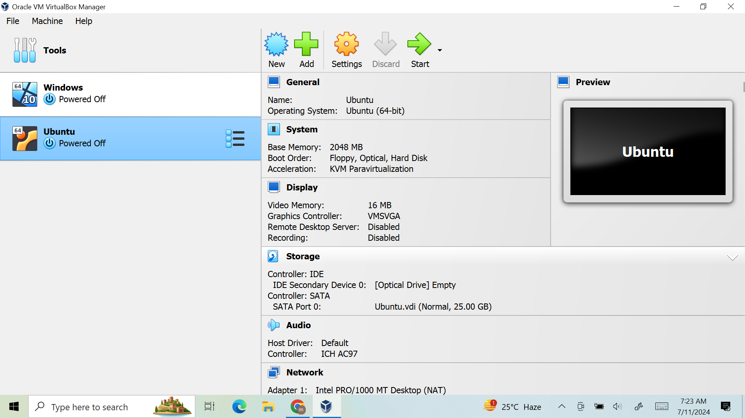

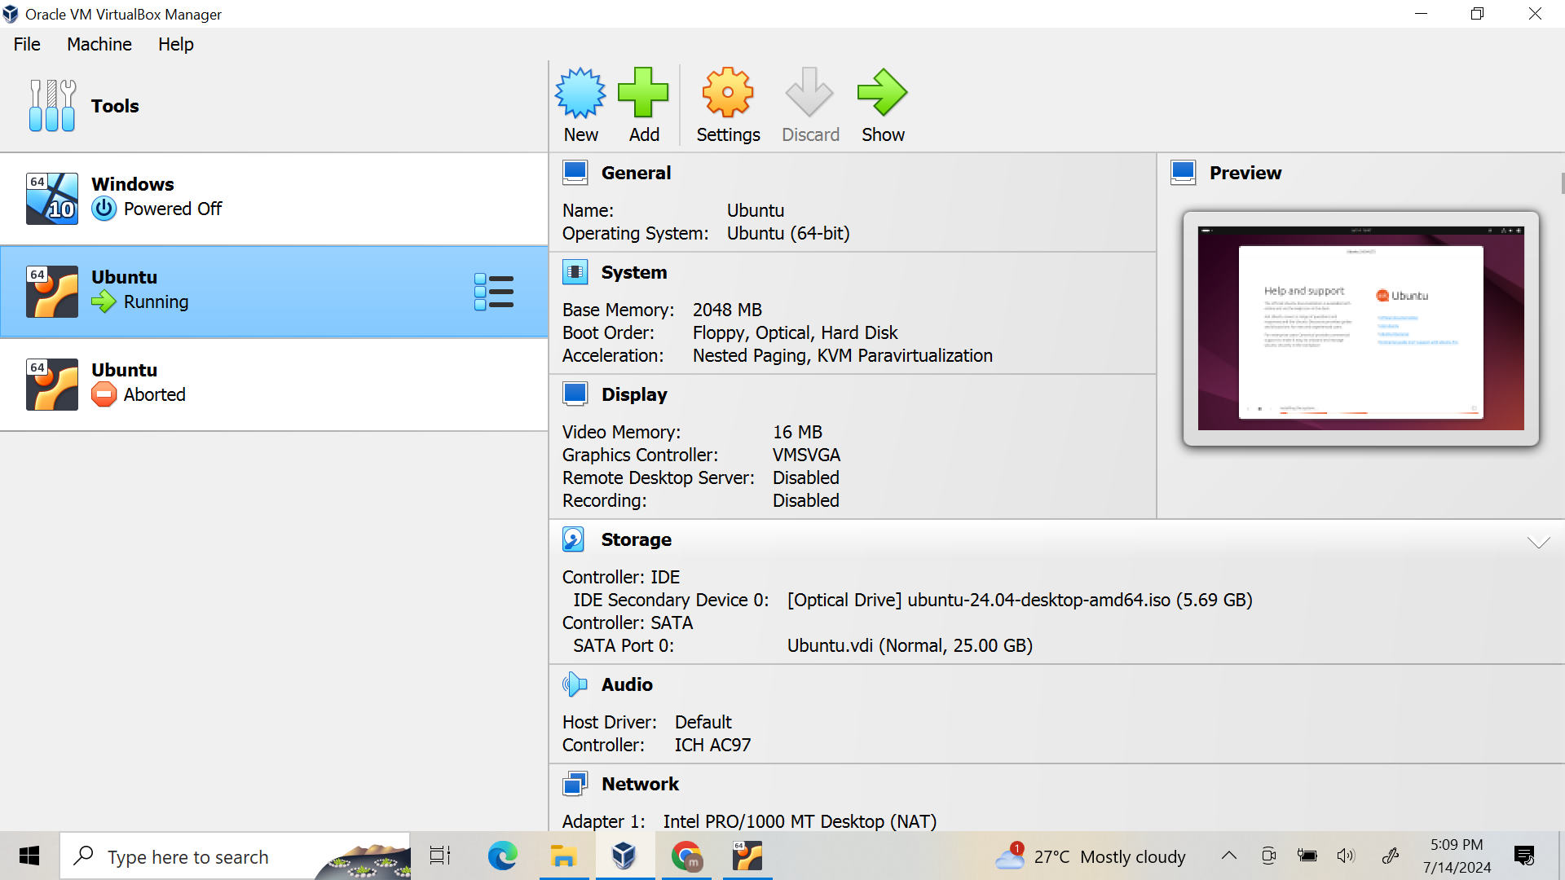

The next steps I followed were as follows:

* Setting up the Visual Studio code on Ubuntu VM
* Setting up Python on Ubuntu VM
* Cloned the Gothub repo - <https://github.com/Vikas098766/Microservices.git>
* Created a virtual environment and installed all the dependencies from the requirements.txt file